Learn how to reduce your Carbon Footprint with
The Fresh Connection in 2012

Does your company have the optimal Carbon Footprint? Have CO2 emissions been effectively linked to company profitability and social sustainability? If not then take The Fresh Connection Challenge to help your company become more profitable.
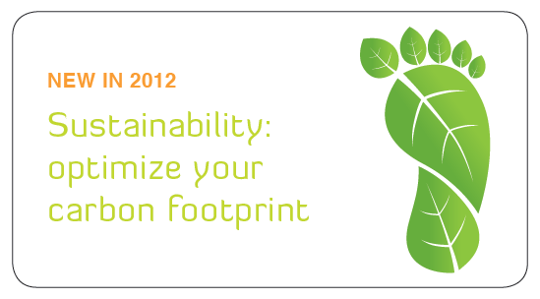
In 2012 The Fresh Connection has shaken things up with the introduction of the challenge to not just maximise the Supply Chain of a fictional juice company with the aim of achievement the highest return on investment, but now CO2 emissions also play a part. The more emissions, the more you pay, and the less customers will buy. This new functionality makes the 2012 National Challenge a very relevant and meaningful learning experience for Australian company with the Carbon tax beginning to hit many companies very hard.
So how to optimise Carbon Footprint in The Fresh Connection? Consider local vs Global sourcing, modes of transportation, full vs partial shipments, warehouse operations and manufacturing policies, agreements with customers, and other policies and processes in the end to end Supply Chain of The Fresh Connection. The 2012 National Challenge not only reveals to participants the need to communicate throughout the Supply Chain and achievement alignment and integration, but also the role that Carbon Footprint plays in company profitability.
Join companies including Caltex, Philip Morris, Sensis, and Mainfreight in the 2012 National Challenge.
Challenge Start Date: 16th April, 2012
Who Participates: Teams of 4 from companies that wish to optimise their value chain and increase business performance.

To learn more about the National Challenge visit:
www.thefreshconnection.com.au
OR contact Matthew Gardner on 03 9010 5754 or email info@iiasiapacific.com
THE FRESH CONNECTION is proudly supported by Transport & Logistics News, MHD Supply Chain Solutions, apics, GS1, 3pi, and Focus Press

